#B-217 Yushima High Town 4-6-12 Yushima,Bunkyo-ku,Tokyo,113-0034,Japan

yuki@mspg.jp

Jan. 8, 2020
Press Release
Mitsuru Sakurai Solo Photo Exhibition in April 2020
Exhibition on the theme of Fe (iron) including award winning works from IPA2019
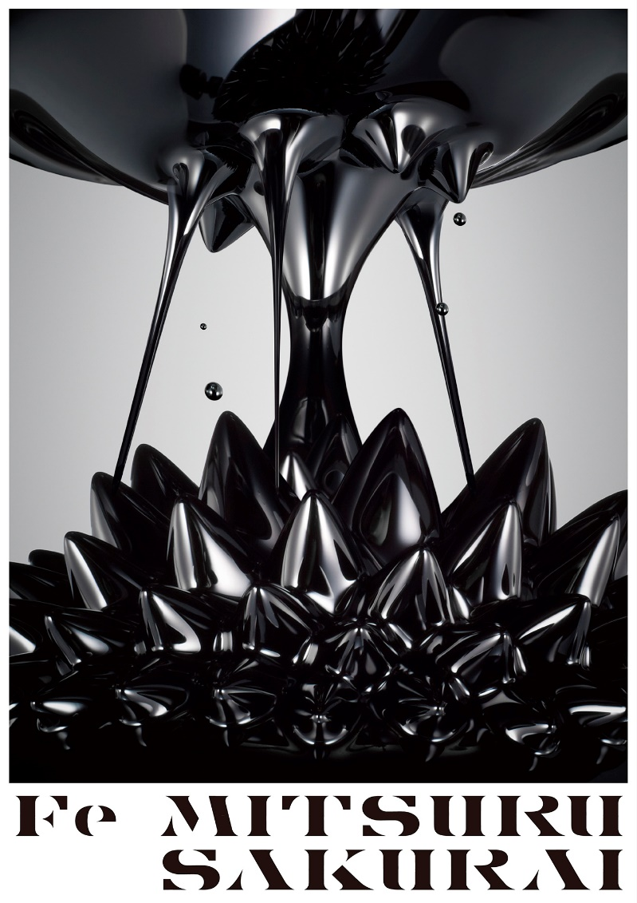
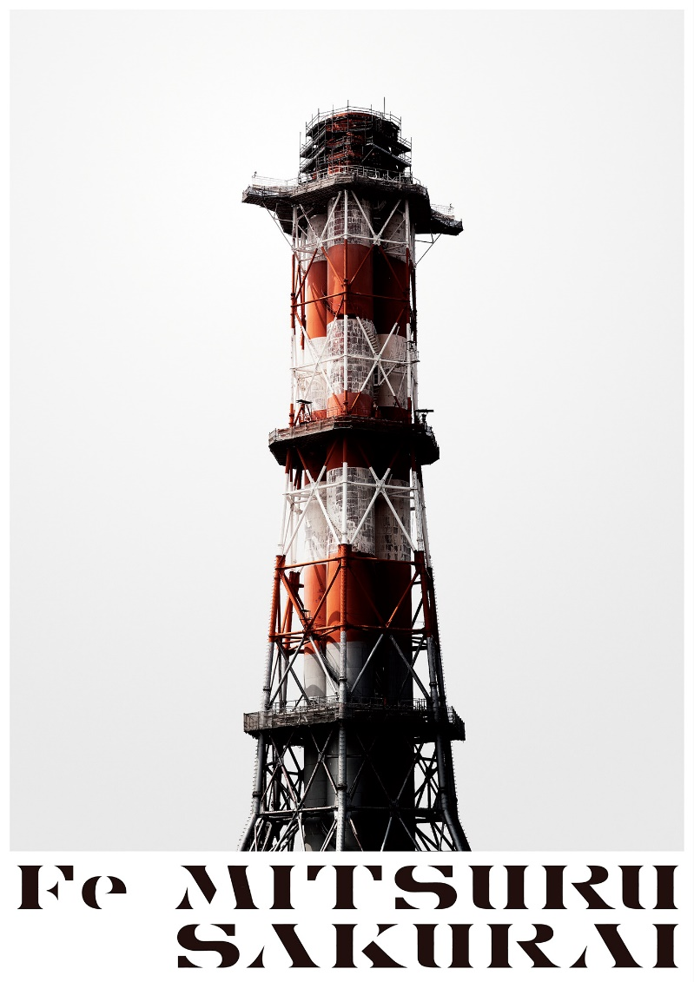

“Fe” is the elemental symbol for iron. Mitsuru Sakurai captures beauty, shape and power which are characteristics of iron.
The photo series won the IPA (International Photography Award) last year (2019). https://photoawards.com/winner/zoom.php?eid=8-173174-19

"Fe"exhibition is composed of two parts: the tower series, which is currently exhibited around the world, and the magnetic force series which began 5 years ago.
This exhibition started from Sakurai’s yearning to be like iron.
Iron is strong, heavy, immovable, and masculine. Sakurai believes that this series will continue develop along with himself throughout his career.

【Exhibition details】
Period: April 8 (Wed), 2020 - April 12 (Sun), 2020
Hours: 10:30-20:30 (Open Everyday)
Admission: Free
Venue: Arts 3331 B104(B1F)
Event: 12(Sun) 17:00-20:00, Closing Party
Web page: http://www.mspg.xyz/exhibition-english
【CV】
Mitsuru Sakurai
Born in 1979 in Tokyo and graduated from Tokyo Zokei University in 2003.
After graduating, he worked at Amana Co., Ltd and studied photography.
He became independent in 2011. MSPG Studio was opened in Yushima, Tokyo.While working on advertising photography. He has won numerous awards.
web site
http://www.mspg.xyz
instagram
https://www.instagram.com/sizzlephotograher

【Venue details】
3331 Arts Chiyoda
6-11-14 Sotokanda Chiyoda-Ku Tokyo 101-0021
Google Map→https://goo.gl/maps/BmL6fJFABe1dk69f7

- 1 min. from Tokyo Metro Ginza Line Suehirocho station (Exit 4)
- 3 min. from Tokyo Metro Chiyoda Line Yushima station (Exit 6)
- 6 min. from Toei Oedo Line Ueno-Okachimachi station (Exit A1)
- 7 min. from JR Okachimachi station (Southern Exit)
- 8 min. from JR Akihabara station (Electric City Exit)

【Contact】
Yuki Oshima
Producer MSPG STUDIO
#B-217 Yushima High Town 4-6-12 Yushima,Bunkyo-ku,Tokyo,113-0034,Japan
E-mail:yuki@mspg.jp

