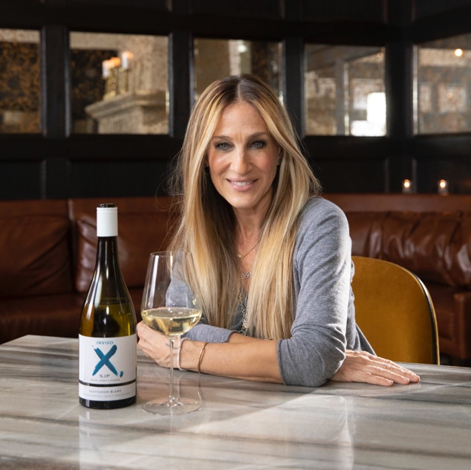
SARAH JESSICA PARKER’S NEW WINE INVIVO X, SJP TO HIT STORES ON SEPTEMBER 18, 2019

The Sauvignon Blanc will be Available Globally & is the First Wine to Launch from her Wine Collection with the New Zealand Winery

NEW YORK, NY (Date) – Actor, designer and wine lover Sarah Jessica Parker has announced today via Instagram (insert hyperlink) that her new Sauvignon Blanc wine in partnership with the New Zealand-based Invivo & Co will hit stores this fall on September 18th, 2019.

With grapes from Marlborough, New Zealand “Invivo X, Sarah Jessica Parker Sauvignon Blanc” suggested retail between $18 - $20 and will be immediately available across the U.S. via national importer Taub Family Selections. At the same time, the wine will also have a global footprint in New Zealand, Australia, Japan, Canada, UK, Ireland and Hong Kong

“I have thoroughly enjoyed the collaboration with Rob and Tim, every part of the process, from our initial conversations discussing wine styles, to the creative process on the brand and label design and of course the Sauvignon Blanc blending session, it’s been one exciting step after another. And a thrilling education in the business of winemaking but more importantly the love and passion behind Invivo.”

“While I’m new to winemaking, the Invivo fellows generously taught, showed and shared as much of the art and science of their business and hopefully I have absorbed some of their Kiwi confidence.
I’m so looking forward to releasing my Invivo X, Sarah Jessica Parker Sauvignon Blanc in September and sharing our wine with the world! And feel very fortunate to have the opportunity offered by Rob and Tim.”

Sarah Jessica Parker’s first ever wine was perfected in May when the founders of Invivo, Tim Lightbourne and Rob Cameron, traveled to New York City for a private blending session with Sarah Jessica to finalize the blend and taste of her new Sauvignon Blanc. They brought the latest samples of the 2019 vintage that was harvested in April from different sub-regions of Marlborough – the home of New Zealand’s world-famous Sauvignon Blanc. Over a three-hour session, Sarah Jessica and the Invivo team finalized the proportions from each vineyard to create the exact blending recipe used in the wine.

WATCH A SNEAK PEEK FROM THE SJP BLENDING SESSION HERE: https://vimeo.com/349806095/f0cc736d10

The new Invivo X, Sarah Jessica Parker Sauvignon Blanc is described by Invivo cofounder & winemaker Rob Cameron as “Lifted notes of grapefruit, honey suckle flower, passionfruit and citrus zest. The palate is expansive and leads with a wall of sweet-scented fruits and a soft but balanced acid spine

As a passionately creative person, Sarah Jessica Parker has naturally been instrumental in both naming the wine and designing the label. The X and the comma that follows references her traditional email and Instagram post signoff of “X, SJ.” Sarah Jessica also hand-painted the X itself, finding teal paint to match the exact shade of one of her favorite satin colorways, "Hamilton", from her SJP Collection label.

Invivo’s other cofounder Tim Lightbourne adds “It has been a pleasure working with Sarah Jessica, its fantastic she has been so hands-on with the whole process and she has a great palate too! Within minutes she was into the blending session and picking subtle differences between the samples. It’s a privilege for us, two old school friends from New Zealand and our winery to work with her, we look forward to a long-term partnership”

In Spring 2020, a Rosé Wine from the South of France will also be added to the Sarah Jessica Parker collection of wines with Invivo and will be a new vintage 2019 blend from the grapes being harvested this September.

“Taub Family Selections is proud to be named the exclusive US importer and agent for Invivo X, Sarah Jessica Parker, an exciting new entry in the expanding NZ Sauvignon Blanc category. Dynamic launch plans are now underway, and Sarah Jessica Parker will be actively involved in marketing the brand and engaging her many fans. We look forward to a long and prosperous future with our new partners!” Marc D. Taub, President & CEO of Taub Family Companies

The wine’s first review – just days after bottling – landed it a 95point rating from New Zealand wine reviewer Sam Kim at Wine Orbit. Kim describes the wine “The palate delivers excellent concentration and weight, wonderfully complemented by fine texture and brilliant focus”

This celebrity partnership is not unchartered territory for the growing New Zealand wine brand as Invivo & Co has also launched a successful wine brand with the UK talk show host Graham Norton. His brand debuted in 2014 selling 12,000 bottles in the first year and now today sells 3.5 million bottles globally. They have also recently extended his brand with the launch of Graham’s new pink Gin earlier this year. Invivo & Co looks forward to growing Sarah Jessica Parker’s collection of wine to reflect her personal preferences and love for wine similar to what they have accomplished with Graham Norton.

GET SOCIAL WITH INVIVO WINES x SJP
Hashtag: #InvivoxSJP
Official Website: www.invivoxsjp.com
Link to Teaser Video feat. SJP: (you can download from this link)
Instagram: @InvivoWines @invivoxsjp
Facebook: Facebook.com/InvivoAndCo
Twitter: @InvivoWines
Instagram Link to Teaser Video (shortened): {INSERT LINK} (you can download from this link)

ABOUT SARAH JESSICA PARKER:
Sarah Jessica Parker is the star and executive producer of "Divorce," returning to HBO for a third hit season. In February 2014, she launched "SJP by Sarah Jessica Parker", a footwear, apparel and accessory label, with partner George Malkemus III. The collection showcases the brand's theme of colors acting as neutrals and encourages women to take risks and break away from fashion rules they imagine. Parker currently serves as the Vice-Chairman of the board of directors for the New York City ballet. She also served on the President's Committee on the Arts and the Humanities under the Obama administration. Parker lives with her husband and three children in New York City.

ABOUT INVIVO:
Invivo’s mission is to bring people together so great things can happen. Invivo has been described as “New Zealand’s most innovative winery.” Founded in 2008 by school friends Tim Lightbourne and winemaker Rob Cameron, Invivo set out to make great wine without the elitist attitude the industry can be known for, they believe that nothing should stand in the way of a great drink. 11 years later, the formula has been a success, with their wines receiving over 200 international wine show medals, distribution in 16 countries and sales of over 3,500,000 bottles. Invivo has also recently released a Gin brand in partnership with Graham Norton. Invivo has played a role in helping New Zealand become the 3rd largest importer of wine into the US (by value) behind France and Italy. USA is New Zealand’s largest export market for wine with $422 million USD in sales. This is an impressive statistic considering that NZ produces less than 1% of all the world’s wine.

www.invivowines.com
www.invivoxsjp.com

PRESS CONTACT
Sabrina Levine Communications
Anne Watkins | Anne@sabrinalevinepr.com | (c): 239.272.2462
Sabrina Levine | Sabrina@sabrinalevinepr.com | (c): 917.769.4434

