European Travel Planning Platform Adds Japanese Language Support

Berlin, July 2019 -- Europe is a fascinating continent to visit, offering history, natural beauty, a wide range of cuisines and diverse cultural attractions. It also has a high class transport network, but one which can be challenging to book onto from outside the continent.

That’s why Omio, formerly GoEuro, the leading search and booking platform for travel by train, bus and flight within Europe, has launched in Japanese, meaning travellers from Japan will be able to travel more easily across the continent, not only to major cities but also to smaller towns and villages.

Research indicates that every year nearly three million people travel from Japan to Europe, however each country has a range of transport providers, different ticket systems and types, as well as different pricing structures. However with Omio it’s possible to book in Japanese, pay with a range of payment methods (including Apple Pay and in local currency in the future).

Since the launch of Japanese website and app, bookings by Japanese travellers have increased by more than 100% within just a month. According to Omio, the most popular countries are Italy, Spain and France:

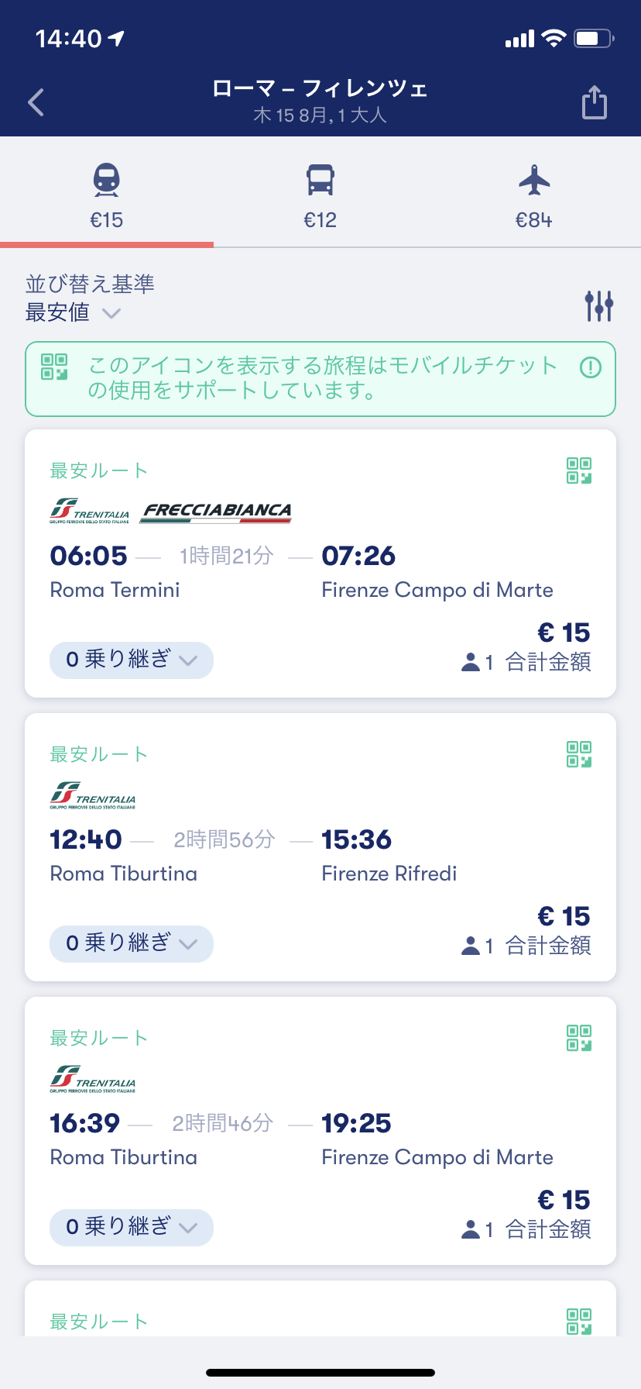

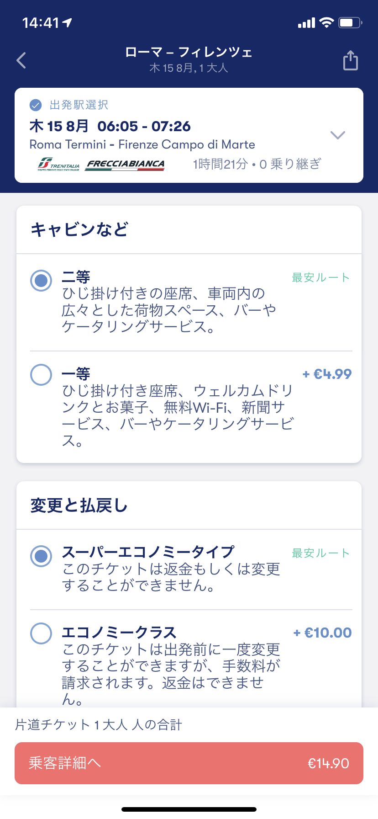

Top 10 Popular Routes in Europe (Japananese Users)
1 | フィレンツェ-ローマ
2 | ローマ-フィレンツェ
3 | ロンドン-パリ
4 | マドリード-バルセロナ
5 | ヴェネツィア-フィレンツェ
6 | パリ-ロンドン
7 | ミラノ-ヴェネツィア
8 | マドリード-トレド
9 | フィレンツェ-ヴェネツィア
10 | パリ-ブリュッセル

Over the coming months Omio will continue to provide more localized support for Japanese travelers, including but not limited to Japanese Yen currency and local payment methods, as well as establishing partnerships with local travel companies and to promote the product via local media platforms.

The company was founded as GoEuro in 2013, and this year rebranded to become Omio, aiming to drive expansion globally.

About Omio

Omio is a travel platform that allows customers to find and book trains, buses and flights across Europe. Partnering with over 800 European transport operators, Omio is revolutionising the travel planning experience, providing customers with more choice, transparent pricing and easier booking.
Omio lets travellers search for any location, including cities, towns and villages, showing the best possible transport combinations while eliminating the need to visit multiple websites to plan an entire trip. With Omio, travel planning is simple, flexible and personal.
The travel startup is headquartered in Berlin with over 300 employees from 45 different countries. The latest funding round totalling $150 million, led by Kinnevik AB, Temasek and Hillhouse Capital, was announced in October 2018.

