Nanotis, the UTokyo-linked start-up, raises \45M from
Shizuoka Capital, Hamamatsu Photonics, and individual investors
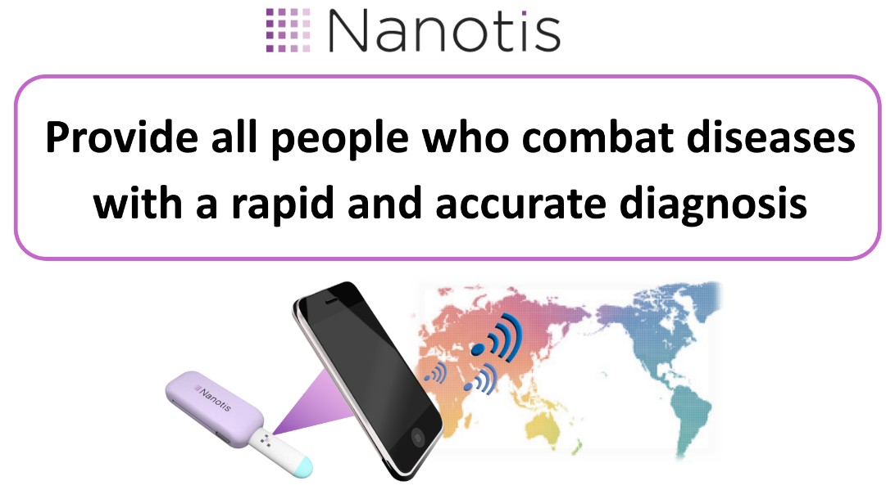
Nanotis (Head Office: Shibuya, Tokyo; CEO, Founder: Lisa Sakashita), the University of Tokyo-related start-up that is developing rapid diagnostic devices for infectious diseases, has raised \45,000,000 JPY (~$400,000 USD) from Shizuoka Capital (Head Office: Shizuoka, Shizuoka; CEO: Akira Hiruma), Hamamatsu Photonics (Head Office: Hamamatsu, Shizuoka; CEO: Akira Hiruma), and individual investors.
Nanotis, which was established in June 2016, is a start-up company related to the University of Tokyo. Our corporate mission is to “Provide all people who combat diseases with a rapid and accurate diagnosis.” Thus far, we have been developing next-generation rapid diagnostic devices for infectious diseases that can be potentially used anywhere and by anyone with high sensitivity. The first target for our devices is influenza, and we will propose a future in which everyone can easily conduct rapid diagnostic tests with high-sensitivity without pain soon after the onset of influenza. In the future, we aim to apply our technology to multiple diseases; we will also propose the development of various services such as novel healthcare systems and epidemiological survey applications using smartphones.
Through this fundraising, we will accelerate research and development to further expand our business and strengthen the recruitment of core human resources such as engineers, researchers, and strategic managers.

- Comment from Lisa Sakashita, CEO of the Nanotis Corporation
How can we deliver accurate announcements to people who are suffering from illnesses as soon as possible, even within a second? This question has led me to promote our business to create innovative rapid diagnostic devices that truly bring value to the medical field. This fundraising has been realized thanks to the wonderful team and everyone who is supporting us from the foundation; it is a great honor for us to receive support from Hamamatsu Photonics, a leading company in photonics technology that has great synergy with our technology, Shizuoka Capital, which has a strong network in Hamamatsu, and angel investors. I am convinced that we can acquire talented people through this funding and establish a platform for innovative research and development.

- Comment from Rinzo Mizutani, President of the Shizuoka Capital Company Limited
Nanotis is made up of talented young members and full of vitality. We highly appreciate Nanotis as a rare existence in the start-up which is developing medical devices, including the point that it also has powerful collaborators to promote research and development. We hope that this fundraising will be the driving force to accelerate the growth of Nanotis.

- Comment from Akira Hiruma, President of the Hamamatsu Photonics K. K.
In April 2018, we established CVC in order to discover new industries applying optical technology by supporting start-up ventures from universities both in Japan and overseas.
I expect that it will be an opportunity to recognize our attitude towards investment and the corporate philosophy not only for the University of Tokyo startup venture company but also many university startup ventures. I would like to work together for Nanotis' research and development by providing the photonics technology and knowledge that we have cultivated.

- Corporate Profile -1
Company Name: Nanotis Corporation
CEO: Lisa Sakashita
Address: 5-50-13 Yoyogi, Shibuya, Tokyo, 151-0053, Japan
Laboratory: The University of Tokyo Engineering Building 4/5, 7-3-1 Hongo, Bunkyo, Tokyo, 113-8656, Japan
Established: June 6th, 2016
Capital Stock: \58,160,000 JPY
Business description: Research and development of rapid diagnostic devices
URL: http://nanotis.net/en

- Corporate Profile -2
Company Name: Shizuoka Capital No. 7 Investment Limited Partnership, Shizuoka Capital Company Limited
President: Rinzo Mizutani
Address: 2-1 Kusanagikita, Shimizu-ku, Shizuoka, Shizuoka, 424-0883, Japan
Established: August 1st, 1984
Total Funds: \1000,000,000 JPY

- Corporate Profile -3
Name: Hamamatsu Photonics K. K.
President: Akira Hiruma
Address: 325-6, Sunayama-cho, Naka-ku, Hamamatsu, Shizuoka, 430-8587, Japan
Established: September 29th, 1953
Capital Stock: \34,928,000,000 JPY

- Contact
Name of contact: Lisa Sakashita, CEO/Founder
Tel: +81-90-9812-7032
E-mail: info@nanotis.net

